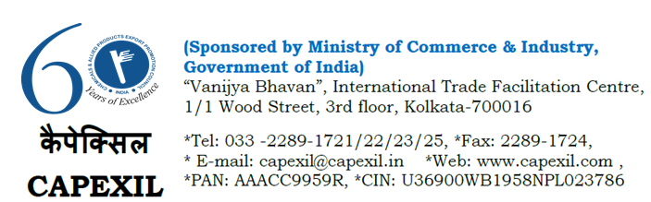
Annex – I
IMPORTERS’ REGISTRATION FORM
REVERSE BUYER SELLER MEETS IN INDIA for CERAMIC PRODUCTS
11 -13 September 2018 at Rajkot and Morbi, Gujarat, India

PART-1

COMPANY DETAILS :
Company

Full Address

Mobile

Telephone

Fax

E-mail

Website
Annual turnover of the Company (in USD / Euro etc.)

Annual Import Turnover (in USD / Euro etc.)

Major products imported with value during 2016-17 & 2017-18. Please indicate ITC HS Codes of the  products imported | HS Code | 2016-17  (In USD/EURO) | 2017-18  (In USD/EURO)
Major importing countries

Mode of payment of Import

Frequency of imports per annum

PART-2

DELEGATE’S DETAILS :
Name of the Foreign Delegate

Designation (Must be of level of Director / Proprietor / Partner / Sr. Executive)

Passport Details Of the Delegate :-
Passport No.
Name as in Passport
Date of Issue
Date of Expiry
Place of Issue
Date of Birth

PART-3

ITEMS/PRODUCTS OF INTEREST :
The Focus Product Sectors for Ceramic Products are as under: | Please tick against your item(s) of  interest for interaction in India
Electro-Porcelain Insulators

Ceramic Tiles

Sanitaryware

Ceramic Colours, Fritz, Glazes

Ceramic Tableware

Ceramic Potteryware & Gift Items

Other Raw Materials of Ceramic
Products
Refractory & Refractory Materials

PART-4

Endorsement by Indian Embassy/High
Commission/Consulate

Date :
Name:
Signature:
Company Seal:

